[Note: this should be stored ultimately as .md in GitHub. Google Docs is just for easy collaboration and iteration]

Authenticated Experience Team Charter

North Star

Deliver self-service tools on par with top private sector companies, and have the best online experience in the federal government

# Product Line

[Authenticated Experience]

# Mission Statement:

[Help users accomplish tasks more easily by leveraging what we know about them as a logged in user.]

Product Portfolio:

* Dashboard
* Profile
* Account
* Notifications
* Login Flows
* In Content Personalization
* Others

# Responsibilities:

Increase Veteran, Caregivers, Dependents, and others easy access to the benefits they deserve.

# Roadmap:

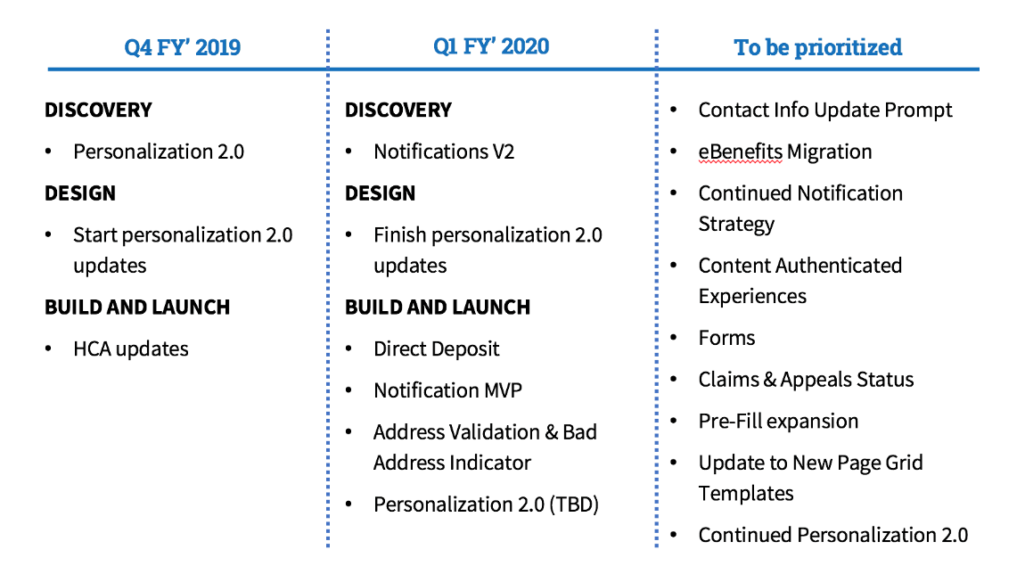

*(Last Updated August 2019)*

Team Members

**DSVA Product Manager:** Lisa Koenigsberg

**Team Product Manager**: Justin Pickett

**Front-End Engineer:** Erik Hansen

**Front-End Engineer:** Amen Ra

**Back-End Engineer:** Lihan Li

**DSVA Designer Lead:** Samara Strauss

**Designer/Researcher:** Arthur Green

Workflow + Cadence

**Stand-up:** people / product check-ins

* Daily @ 3pm (except Tuesdays)
* 15 min

**Sprint Planning:** outline team and member focus, goals for sprint

* 1st Wednesday of every sprint
* 1 Hour

**Retro:** review accomplishments from prior sprint, what went well, areas for improvement

* 1st Wednesday of every sprint
* 30 min

**Grooming:** assess and update workload for remainder of sprint

* 2nd Wedsnesday of every sprint
* 1 Hour

**Issue Etiquette**

* For an issue to go into the Current Sprint column, it must have the following (created using the “Standard Issue Template”):
  + Estimate
  + Title that explains task
  + Description with Background and Acceptance Criteria
  + Labels - Analytics-Insights, Call Center, Analytics Request
  + User Story, Goal, Acceptance Criteria - please fill out the Goal and any known acceptance criteria. The PM will revise as necessary.
  + Epic assigned
* All work should be validated either in staging or production, as defined by the acceptance criteria. Each ticket's last comment before closing should reflect whether validation has occurred, and by whom. By default, assign your PM to validate any tasks you are unable to validate yourself.
* If there is a new RED LIGHT URGENT work request, contact the Product Manager and ask for help to work it into the sprint

**Estimation**

Estimation is not based on how long something will take to complete, but is rather a combined rating encompassing risk, LOE, and complexity.

1 - Easy task, work is known, can be executed quickly

2

3

5 - Becoming complex

8

13 - Very complex, may take a full sprint or longer

21

40 - Needs to be broken down into smaller tickets

Team Norms

* Be respectful, both online and off
* Show your face (Webcam) at meetings / calls
* Speak up! - everyone’s voice matters
* We are flexible, but intentional in the way we work
* Let’s have fun and do great work!

**And some logistics:**

* Keep as much Slack conversation in public channels as possible, to minimize duplicative and extraneous communication.
* GitHub is the single source of truth. Every body of work should be documented for tracking and capacity planning.
* Update tickets regularly. If conversations happen in Slack that are pertinent to an issue or useful to document, copy them into GitHub.
* Our tickets/issues have an estimated level of effort, clear acceptance criteria, and an individual or team assignee before being put in a sprint.
* Extra time? Explore the "Ready" column in ZenHub.

Role-Related Knowledge / Best Practices

**Engineering:** <https://github.com/department-of-veterans-affairs/vets.gov-team/tree/master/Work%20Practices/Engineering>

**Design:** <https://github.com/department-of-veterans-affairs/vets.gov-team/tree/master/Work%20Practices/Design>

**Product:** <https://github.com/department-of-veterans-affairs/vets.gov-team/tree/master/Work%20Practices/Product%20Management>